

|  |  |  |  |  |  |  |  |  |  |  |  |
| --- | --- | --- | --- | --- | --- | --- | --- | --- | --- | --- | --- |
| |  |  | | --- | --- | | Contact | Dr. Robert M. McNab | | Telephone | 757.683.3153 | | Email | rmcnab@odu.edu | | Website | http://www.ceapodu.com | |  |  | | FOR IMMEDIATE RELEASEJuly 24, 2018 |

Virginia GDP grows at 2.4% annualized rate in Q1 2018

**Increases in Manufacturing and Information Contribute to Sustained Growth**

Norfolk, VA, July 24, 2018 – The Virginia economy outperformed the national economy in the 1st quarter of 2018 with the 4th consecutive quarter of real Gross Domestic Product (GDP) growth above 2 percent. The real (inflation-adjusted) measure of economic activity released today provides further evidence of a sustained recovery in Virginia and the continuing economic expansion across the United States.

After a slow start in the 1st quarter of 2017, the Virginia economy has posted annualized quarterly rates of economic growth of 2.8% (2nd Quarter 2017), 3.7% (3rd Quarter 2017), 2.5% (4th Quarter 2017), and 2.4% (1st Quarter 2018). In the first quarter of 2018, Virginia ranked 12th in terms of real GDP growth among U.S. states and the District of Columbia, a substantial improvement from earlier in the decade where Virginia lagged national growth.

**Virginia is poised to grow throughout 2018. The Fiscal Year (FY) 2018 federal budget significantly increases the allocation to the Department of Defense, which has a significant presence in the Commonwealth. Recent announcements of new capital infrastructure projects also highlight improving business conditions. Virginia also moved up to 4th place in a CNBC survey of state business conditions, another signal of the improving economic climate in the Commonwealth.**

Private industry continued to generate most of the economic growth in the Commonwealth in the 1st quarter of 2018. Of the 2.4 % growth in real GDP, private industry accounted for 2.14%. As illustrated in Table 1, manufacturing, construction, and agriculture made the most significant contributions to 1st quarter growth. While utilities, wholesale trade, administrative and support services, arts and entertainment services, and accommodation and food services declined in the 1st Quarter 2018, these relatively small declines were offset by the larger gains in other sectors. The government and government enterprises sector also contributed positively to 1st quarter growth.

With the passage of the Bipartisan Budget Act of 2018 and the Tax Cuts and Jobs Act of 2017, we expect the Virginia economy will continue to improve throughout 2018 and into 2019. Increases in federal discretionary spending, especially with respect to the Department of Defense, will undoubtedly spur economic growth in Northern Virginia and Hampton Roads. We also expect that the Richmond metropolitan area will continue to grow in 2018. Given that these three metropolitan areas comprise more than two-thirds of Virginia’s economic activity, growth prospects for Virginia are promising.

We continue to monitor the operations of the federal government. Because approximately thirty percent of Virginia’s GDP is tied to the federal government, uncertainty with regards to policy or appropriations can have a chilling influence on Virginia’s economic prospects. We are increasingly concerned about the rapid rise in the federal government’s operating deficit and the accumulation of public debt. While there is substantial disagreement when a downturn might occur, there is an emerging consensus on two things. First, the federal government’s fiscal position is dramatically worse than prior to the Great Recession. Second, this means that the federal government will have much less flexibility available to it to combat recessionary economic conditions. A downturn in federal revenues and increase in expenditure demands due to an economic downturn may inhibit the ability of the federal government to respond in the future. We believe now is the appropriate time to continue to increase Virginia’s revenue stabilization fund in anticipation of the next economic downturn.

We are also increasingly troubled by the prospects of a global trade war. The imposition of tariffs by the U.S. and counter-tariffs by its training partners has already resulted in the fall of soybean, pork, and other commodity prices. The proposed tariffs on imported automobiles and automobile parts would undoubtedly curtail traffic into the Port of Virginia and possibly chill coal exports. In the short-term, we expect minor dislocations of production and trade, however, there remains the possibility that the current economic expansion is curtailed by the current tariff-based trade policy.

# # #

The Dragas Center for Economic Analysis and Policy in the Strome College of Business at Old Dominion University undertakes a wide range of economic, demographic, transportation and defense-oriented studies. For eighteen years, the Center and its predecessors have produced the highly regarded State of the Region Report for Hampton Roads and economic forecasts for the region. If you would like more information about this topic, please contact Dr. Robert M. McNab at 757.683.3153 or email at rmcnab@odu.edu.

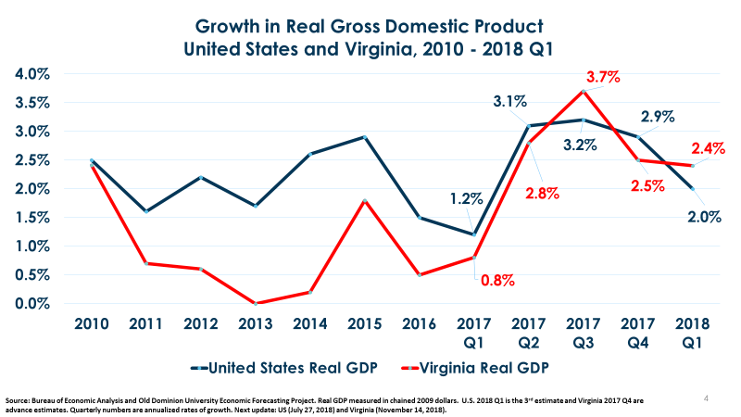

**Virginia Annualized Real GDP Growth Rate Contributions by Industry Sector by Quarter**



**Source: Bureau of Labor Statistics, 2018 and Dragas Center for Economic Analysis and Policy**